YOUR NEXT GATEWAY IS JUST A HOME AWAY

DISCOVER THE SECRETS OF LAND OF THOUSAND HILLS: Known as the land of a thousand hills, Rwanda’s stunning scenery and warm, friendly people offer unique experiences in one of the most remarkable countries in the world. It is blessed with extraordinary biodiversity, with incredible wildlife living throughout its volcanoes, montane rainforest and sweeping plains.

Travellers come from far and wide to catch a glimpse of the magnificent gorillas, yet there is so much more to see and experience. Book a tour with Travel Team Rwanda today and see the amazing secrets that you have never dreamt of.

KIGALI GENOCIDE MEMORIAL: A MONOUMENT OF LASTING PEACE:

Inaugurated in 2004, the Kigali Genocide Memorial at Gisozi is the final resting place for more than 250,000 victims of the Genocide against the Tutsi. This memorial also serves to educate about how the Genocide against the Tutsi took shape and examines genocide in the 20th century.

NYANDUNGU URBAN WETLAND: FIND A PLACE TO CALL HOME WHEN YOU ARE AWAY FROM HOME

Nyandungu Urban Wetland Eco-Tourism Park is composed of ornamental ponds, gallery forests, medicinal plant gardens, paved walk ways and cycle lanes, restaurants, information center, recreational and other biodiversity services. Its idle for a quite time, time of sober reflection, a time to be close to nature once again in your lifetime.

It was built with the idea of supporting innovative approaches to restore and conserve wetland ecosystems on 120 Ha of land organized in 5 sections. Once in, you are welcomed by a medicinal garden which showcases indigenous and native plants that have been found to possess medicinal value. Next, is the Papal Garden, whose name is derived from the historic visit by Pope John Paul II to Rwanda in 1990. During his visit 30 years ago, it is at the same place that the Pope read his homily to Rwandans.

In the park, there are various water ponds located in the park named after different lakes in Rwanda including Muhazi, Kivu, Ruhondo and Ihema which provide a comfortable place for visitors to take a health break amidst the serene natural environment. Birds of diverse species and butterfly species are another good sight to the wetland.

Call it a Visit to THE GARDEN OF EDEN.

CONVENTION CENTER: YOUR NEXT GATEWAY IS JUST A HOME AWAY.

The iconic Kigali Convention Centre (KCC), is the premium events venue in Rwanda since its opening in 2016 and a must visit when in Rwanda. It attracts a lot of tourists on a daily basis. The multifaceted design reflects a true Rwandan homestead. The dome shape Auditorium, reproduces a hut in the Kings Palace and boasts a capacity of 2600 guests, whereas, the hotel architectural façade replicates a traditional and colorful weaved basket. Despite this nod to the past the center also boasts cutting-edge technology, high speed internet, and audio-visual equipment’s expected of a world class facility. The Convention Centre is one of the largest in the region.

A wide variety of gastronomical facilities are offered to the guests such as Auditorium Club, the exclusive Business Class Lounge, Piazza Bar & Filini Restaurant a passionately Italian restaurant that provides a unique mix of sophistication and casual design.

PLACES TO VISIT

AKAGERA NATIONAL PARK:

The Akegera National Park is another amazing natural piece and wonder. A visit to Rwanda is incomplete without a sight of this beautiful natural scape. The relatively warm and low-lying plains of Akagera comprise savannah, woodland, wetland and a dozen lakes. In partnership with African Parks, it can boast of lions, rhinos, elephants, giraffes, zebras and other animal species.

The African BIG FIVEs are on the wait for you.

NYANDUNGU URBAN WETLAND

Nyandungu Urban Wetland Eco-Tourism Park is composed of ornamental ponds, gallery forests, medicinal plant gardens, paved walk ways and cycle lanes, restaurants, information center, recreational and other biodiversity services. Its idle for a quite time, time of sober reflection, a time to be close to nature once again in your lifetime.

It was built with the idea of supporting innovative approaches to restore and conserve wetland ecosystems on 120 Ha of land organized in 5 sections. In the park, there are various water ponds located in the park named after different lakes in Rwanda including Muhazi, Kivu, Ruhondo and Ihema which provide a comfortable place for visitors to take a health break amidst the serene natural environment. Birds of diverse species and butterfly species are another good sight to the wetland.

LAKE KIVU

Part of Africa’s Great Rift Valley, Lake Kivu in the west of Rwanda is surrounded by magnificent mountains and has deep emerald green waters covering a surface area of 2,700 km2. It is Rwanda’s largest lake and the sixth largest in Africa.

In the northern edge of Lake Kivu is a town called Gisenyi, an hour’s drive from Volcanoes National Park and the perfect place to relax after gorilla trekking. Once a colonial beach resort of note, Rubavu’s waterfront is lined with fading old mansions, hotels and trendy bars on the lakeshore, ideal for sundowner cocktails. Also the town of Karongi, half way along the lake, is a popular beach resort with hillsides covered in pines and eucalyptus serve as a backdrop to the sparkling lake. At dawn and dusk, the sound of local fisherman singing carries across the water as they paddle in unison.

From Rubavu in the north, the Congo Nile Trail extends 227 kilometers of breathtaking landscapes all the way to Rusizi in the south of Lake Kivu. The trail gently curves back and forth as it weaves through hills and mountains beside the lake with eucalyptus trees lining the road and every inch of the hills seemingly terraced with bananas.

For adventurous travelers, an exciting way to explore Rwanda is a kayaking tour on Lake Kivu, or mountain biking or hiking one of the 6 off-the-beaten path stages of the spectacular Congo Nile Trail.

NYUNGWE NATIONAL PARK

One of the oldest rainforests in Africa, Nyungwe is rich in biodiversity and spectacularly beautiful. The mountainous region is teaming with wildlife, including a small population of chimpanzees as well as 12 other species of primate, including the L’Hoest’s monkey endemic to the Albertine Rift.

With 15 trails, some of which are detailed here, along with various other activities, visitors can choose to sample the delights of the forest or indulge themselves for a week or more in one of Africa’s most stunning forests.

Primate tracking tops most visitor’s list, but it’s worth lingering a little longer for those with time to relax and take in the primal atmosphere.

Botanists will marvel at the 1,068 plant species and 140 orchids. The birdwatching is among the best in Africa with 322 birds species including Red-collared Babbler and 29 other Albertine Rift Endemic species. Butterflies are also a common sight, with at least 120 species.

There are 75 known mammals in Nyungwe, such as the cerval cat, mongoose, congo clawless otter and leopard to name but a few. Many tend to be shy so sightings are luck of the draw.

Memorable and photogenic moments include walking up to the Isumo waterfall or along the Canopy Walk suspension bridge. Tea plantations border the edges of the park, with a habituated troop of Ruwenzori colobus monkeys at Gisakura as well as forest fringe birds.

VOLCANOES NATIONAL PARK

A great and iconic old volcanoes towering almost 15,000 feet, and nearly covered with rich, green rainforest – the Virungas.” Situated in the far northwest of Rwanda, Volcanoes National Park protects the steep slopes of this magnificent mountain range – home of the endangered mountain gorilla and a rich mosaic of montane ecosystems, which embrace evergreen and bamboo forest, open grassland, swamp and heath.

Volcanoes National Park is named after the chain of dormant volcanoes making up the Virunga Massif: Karisimbi – the highest at 4,507m, Bisoke with its verdant crater lake, Sabinyo, Gahinga and Muhabura. Tracking endangered mountain gorillas through the mysterious intimacy of the rain forest, alive with the calls of 200 species of colorful birds and chattering of the rare golden monkey, is only one of the truly unique experiences in the area.

Within the boundaries of Volcanoes National Park are Buhanga Eco-Park, an ancient forest holding Rwanda’s most intriguing folklore and Musanze Caves, formed 62 million years ago after the last estimated volcanic eruption. Hiking, canoeing, mountain biking and village experiences offer something for everyone to enjoy.

TO BUY PERMIT, CONTACT TRAVEL TEAM RWANDA

PACKAGES

5 DAYS GORILLAS & LAKE KIVU TOUR

Destinations: Kigali, Musanze, Lake Kivu, Gisenyi

Age Range: 15- to 75-year-olds

Travel Style: [Family](https://www.tourradar.com/i/rwanda-family), [Private](https://www.tourradar.com/i/rwanda-private), Group & Fully Guided.

Operated in: English

Price per day: $500

Duration: 5 days

Amount: $2500

Tour ID:

Itinerary:

The Tour Starts and end in Kigali! With the Wildlife tour 5 Days Rwanda Gorillas & Lake Kivu Tour, you have a 5 days tour package taking you through Kigali, Rwanda and 3 other destinations in Rwanda. 5 Days Rwanda Gorillas & Lake Kivu Tour includes accommodation, an expert guide, meals, transport and more.

For detailed Brochure on this Trip, Contact Us through ……

Operator: Travel Team Rwanda Ltd

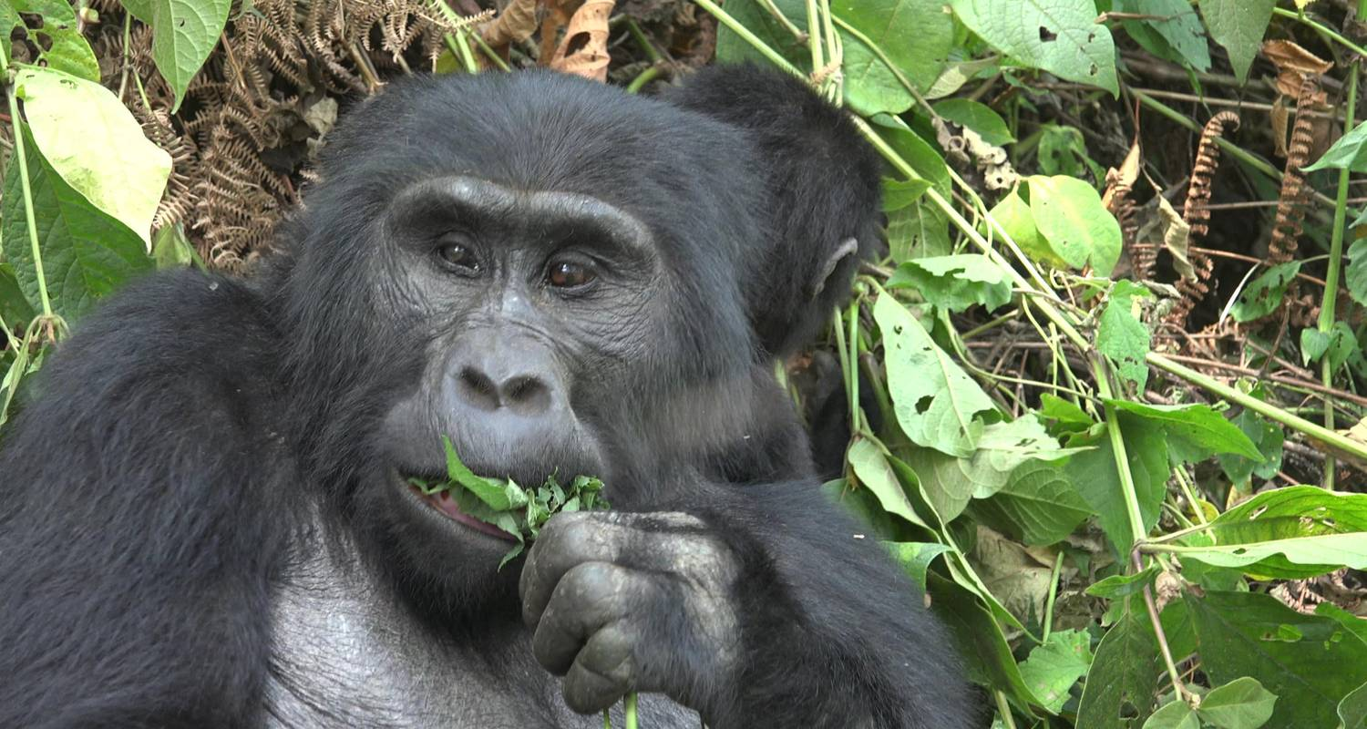

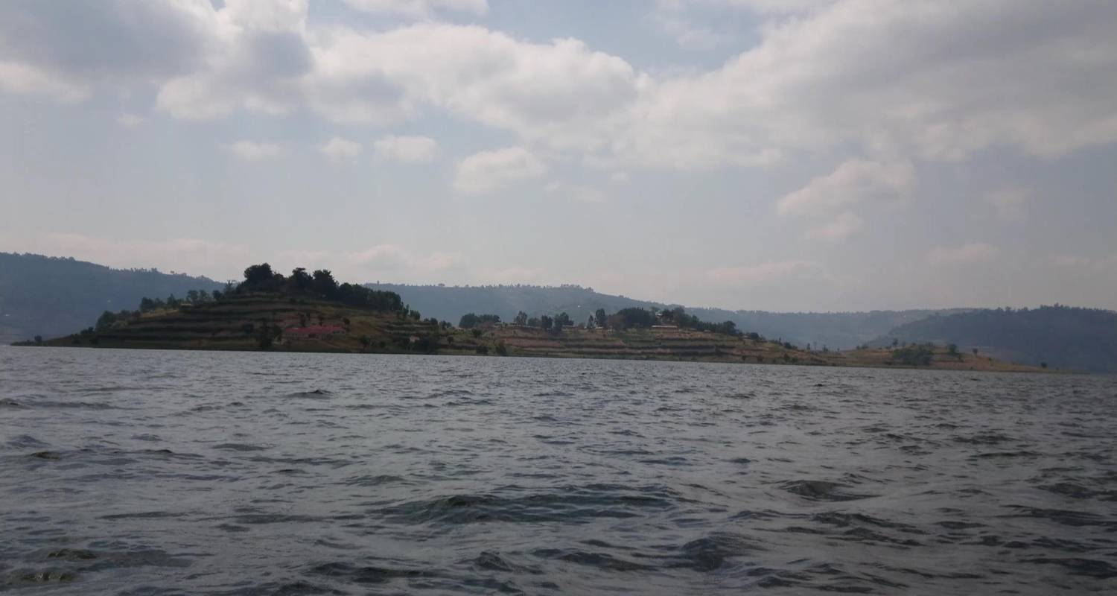

NB: this will be with slide pictures about 3

3-DAY AKAGERA NATIONAL PARK WILDLIFE SAFARI

Destinations: Kigali, Akagera National Park

Age Range: 5- to 70-year-olds

Travel Style: [Family](https://www.tourradar.com/i/rwanda-family), [Private](https://www.tourradar.com/i/rwanda-private), [Fully Guided](https://www.tourradar.com/i/rwanda-fully-guided), [Relaxing](https://www.tourradar.com/i/rwanda-relaxing),

Operated in: English

Price per day: $500

Total package of 3 days: $1500

Tour ID:

Itinerary:

Start and end in Kigali! With the Safari tour 3-Day Akagera National Park Wildlife Safari, you have a 3 days tour package taking you through Kigali, Rwanda and Akagera National Park, 3-Day Akagera National Park Wildlife Safari includes accommodation in a hotel as well as an expert guide, meals, transport and more.

For detailed Brochure & Availability of this tour, contact Us through………….

Operator: Travel Team Rwanda Ltd

**NB: this will be with slide pictures about 3**

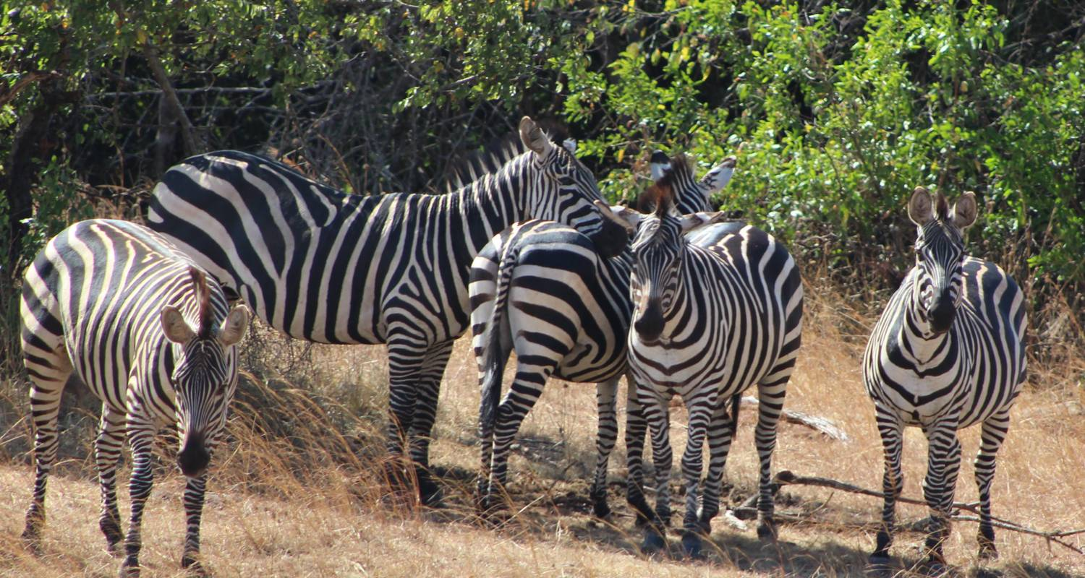

3 D AYS NYUNGWE FOREST CHIMPANZEES TOUR

Destinations: Kigali, Nyungwe Forest

Age Range: 15- to 70-year-olds

Travel Style: [Family](https://www.tourradar.com/i/rwanda-family), [Private](https://www.tourradar.com/i/rwanda-private), [Group](https://www.tourradar.com/i/rwanda-group)

Operated in: English

Tour length: 3 days

Price per day: $300

Total package: $900

Itinerary:

Start in Kigali and end in Nyungwe Forest! With the Hiking & Trekking tour 3 Days Nyungwe Forest Chimpanzees Tour, you have a 3 days tour package taking you through Kigali, Rwanda and Nyungwe Forest,. 3 Days Nyungwe Forest Chimpanzees Tour includes accommodation, an expert guide, meals, transport and more.

For detailed Brochure & Availability of this tour, contact Us through………….

Operator: Travel Team Rwanda Ltd

2 DAY AKAGERA NATIONAL PARK SAFARI

Destinations: Kigali, Akagera National Park

Age Range: 5 to 99 year olds

Travel Style: [Family](https://www.tourradar.com/i/rwanda-family), [Wildlife](https://www.tourradar.com/i/rwanda-wildlife), [Group](https://www.tourradar.com/i/rwanda-group)

Tour length: 2 days

Price per day: $450

Total package: $900

Itinerary:

Start and end in Kigali! With the Safari tour 2 Day Akagera National Park safari, you have a 2 days tour package taking you through Kigali, Rwanda and Akagera National Park, 2 Day Akagera National Park safari includes accommodation, meals, transport.

Operated in: English

For detailed Brochure & Availability of this tour, contact Us through………….

Operator: [Travel Team Rwanda Ltd](https://www.tourradar.com/o/kawira-safaris-ltd)

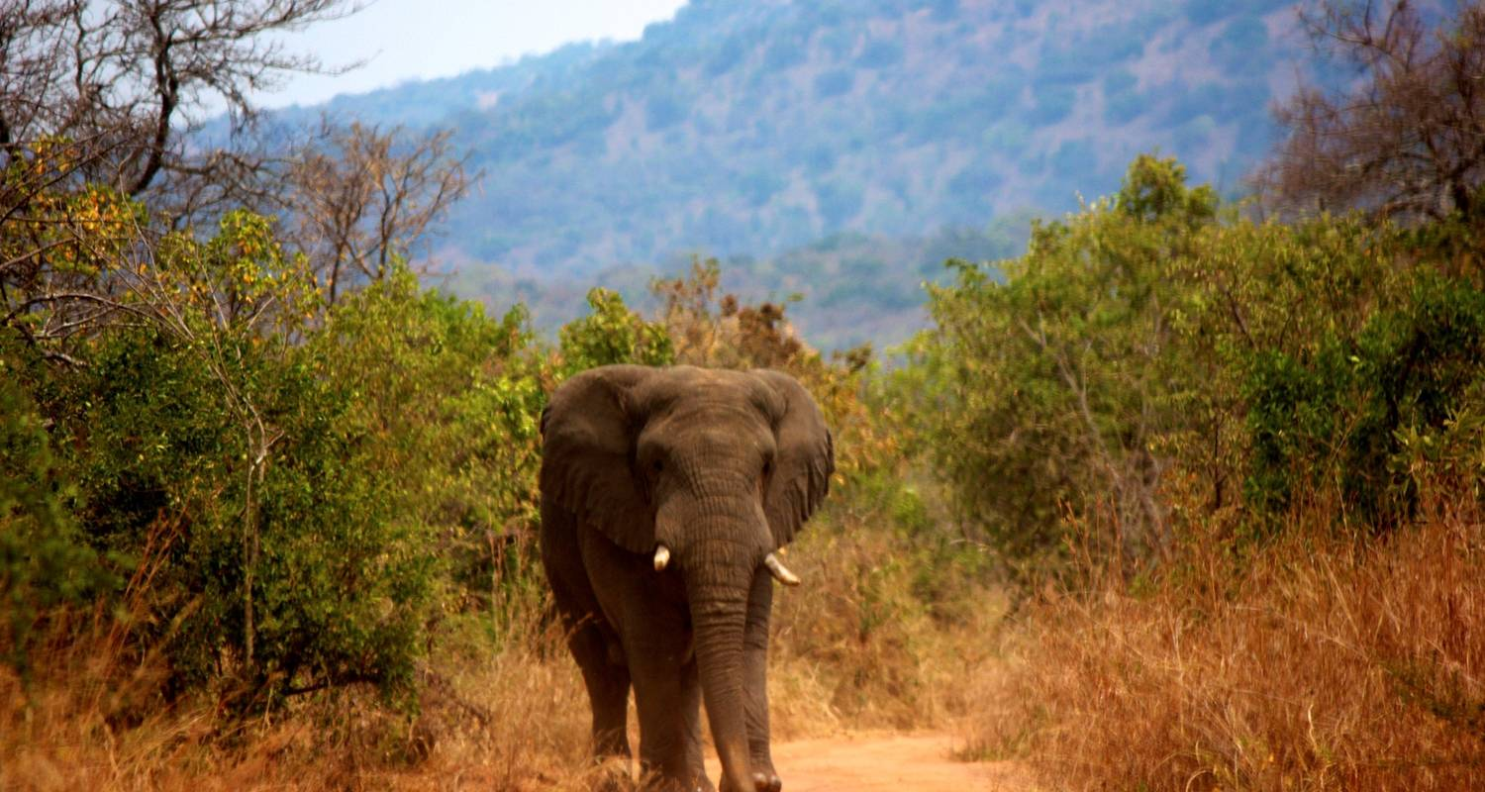

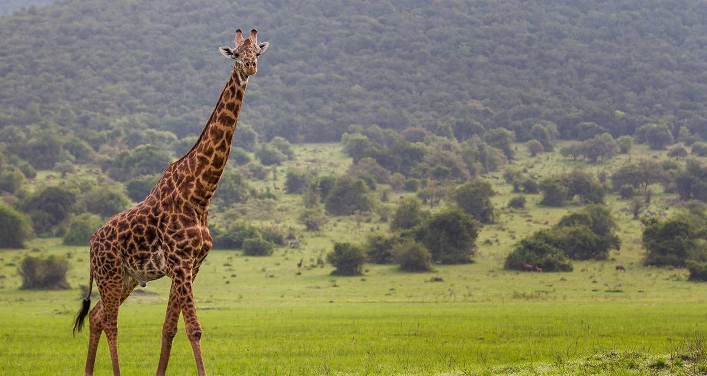

4 DAYS GORILLA TREKKING, BIG 5 & BIG CATS

Destinations: Kigali, Akagera National Park, Musanze

Age Range: 15 to 85 year olds

Travel Style: [Family](https://www.tourradar.com/i/rwanda-family), [Private](https://www.tourradar.com/i/rwanda-private), [Group](https://www.tourradar.com/i/rwanda-group)

Operated in English

Tour length: 4 days

Price per day: $887

From: $3540

10% Deposit Required.

Itinerary:

Start and end in Kigali! With the Safari tour 4 Days Gorilla Trekking, Big 5 & Big Cats in Rwanda Tour, you have a 4 days tour package taking you through Kigali, Rwanda and 2 other destinations in Rwanda. 4 Days Gorilla Trekking, Big 5 & Big Cats in Rwanda Tour includes accommodation, an expert guide, meals, transport and more.

For detailed Brochure & Availability of this tour, contact Us through………….

Operated by Travel Team Rwanda

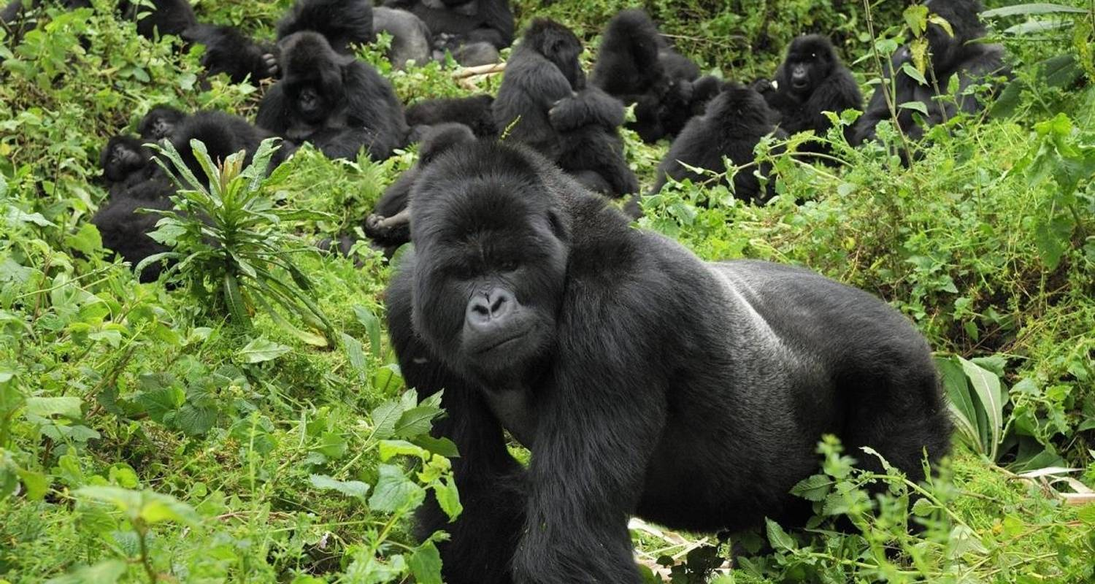

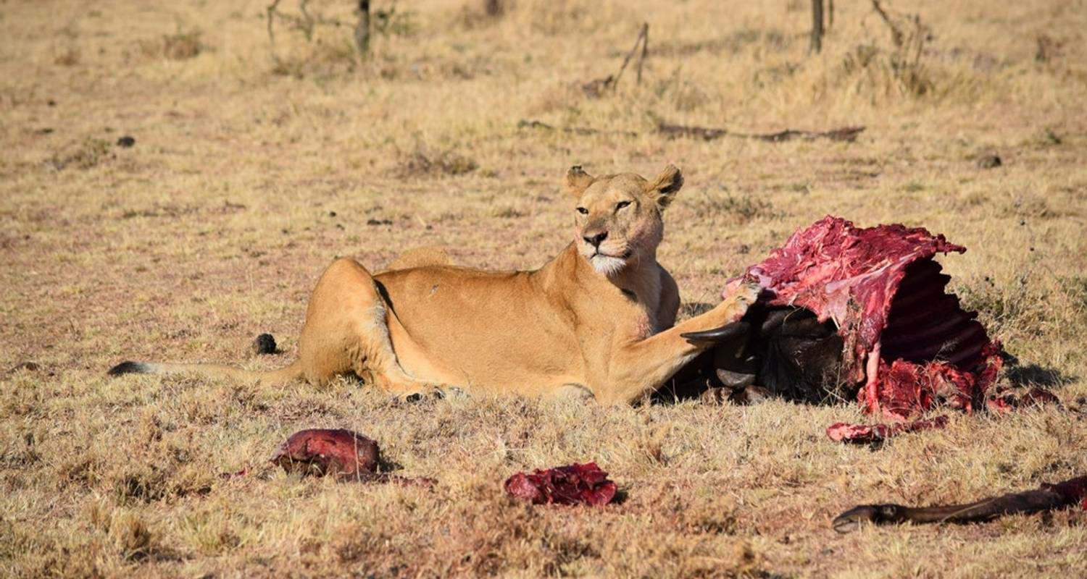

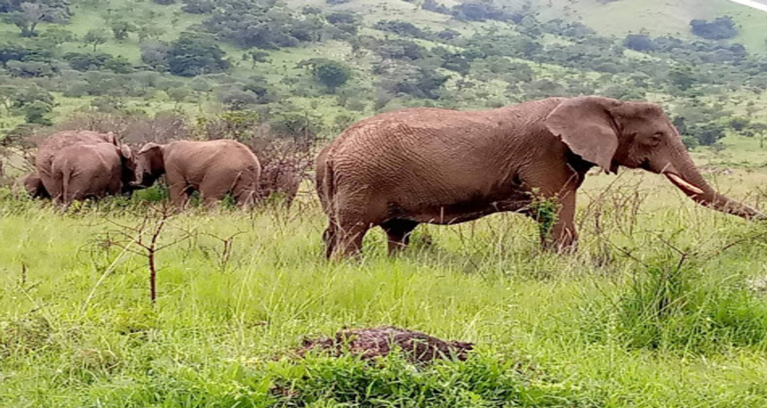

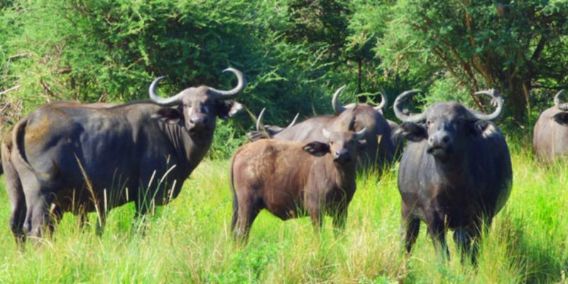

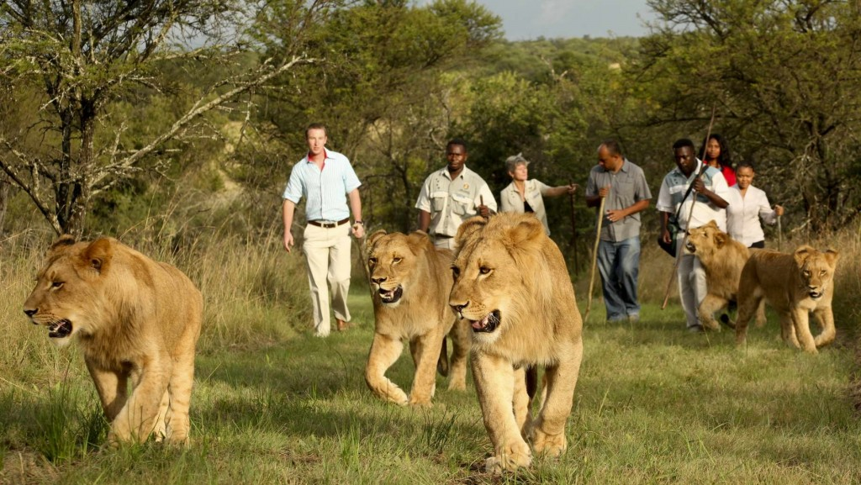



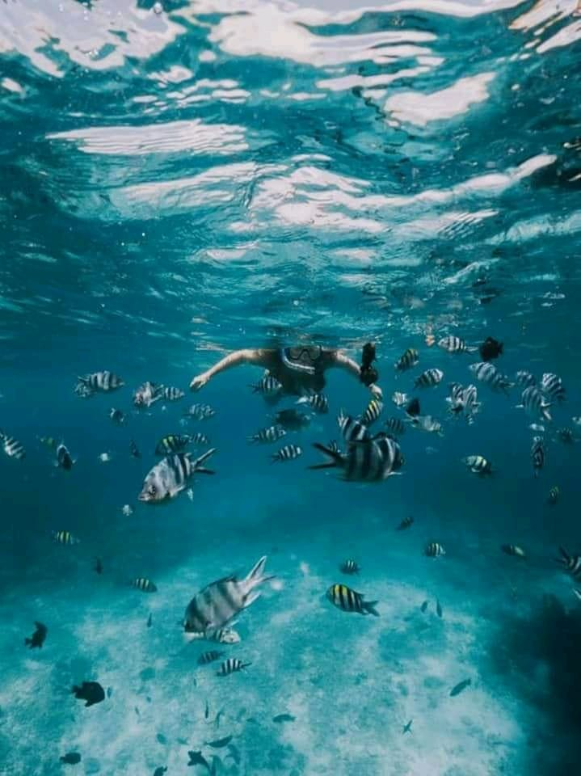

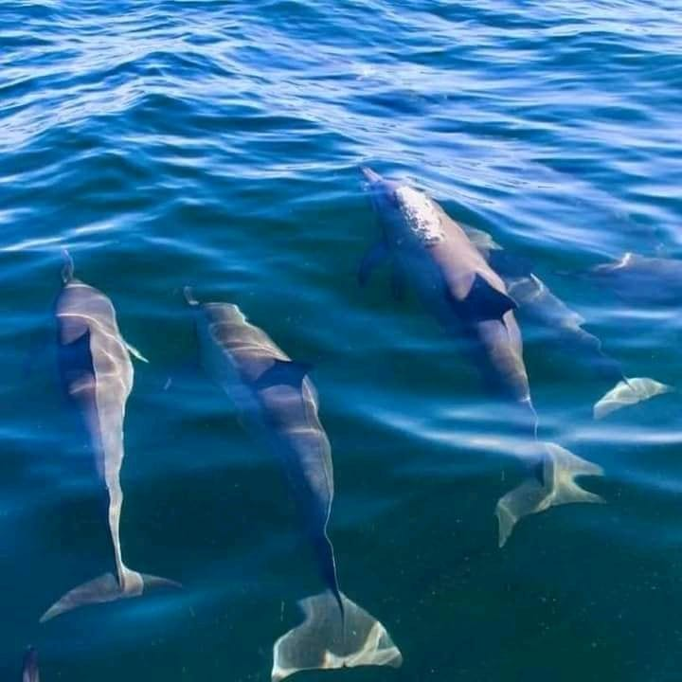

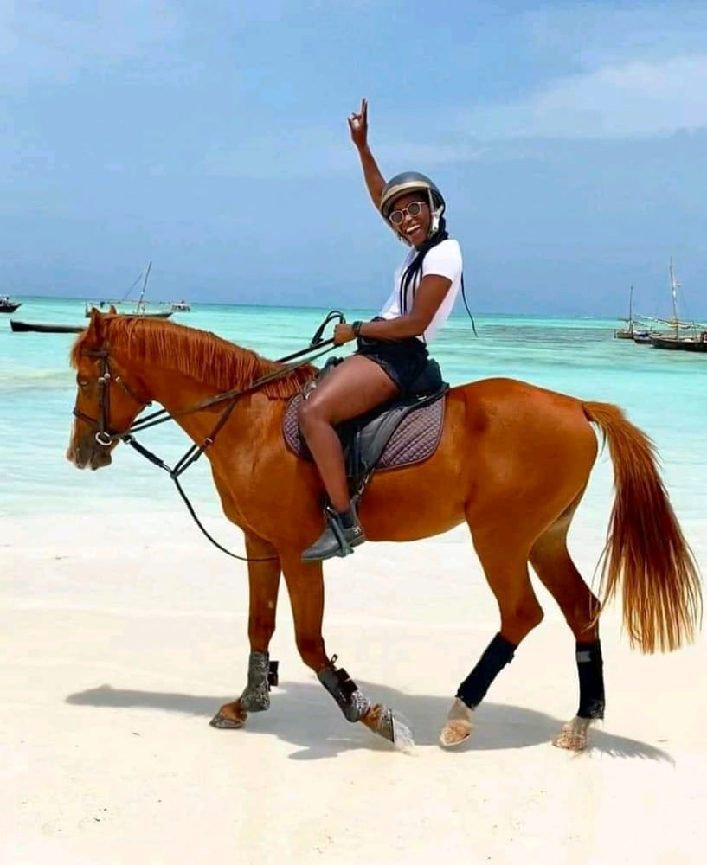

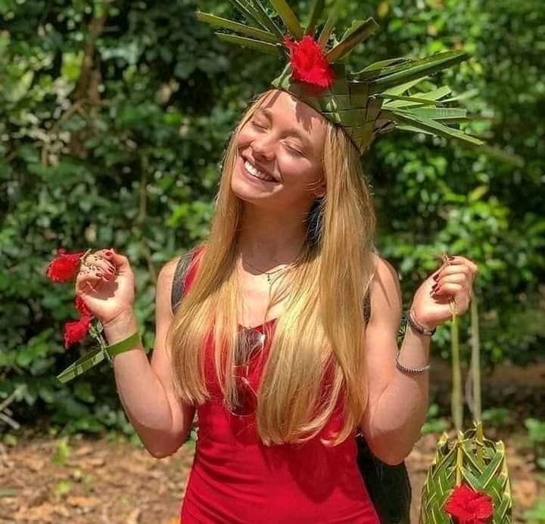

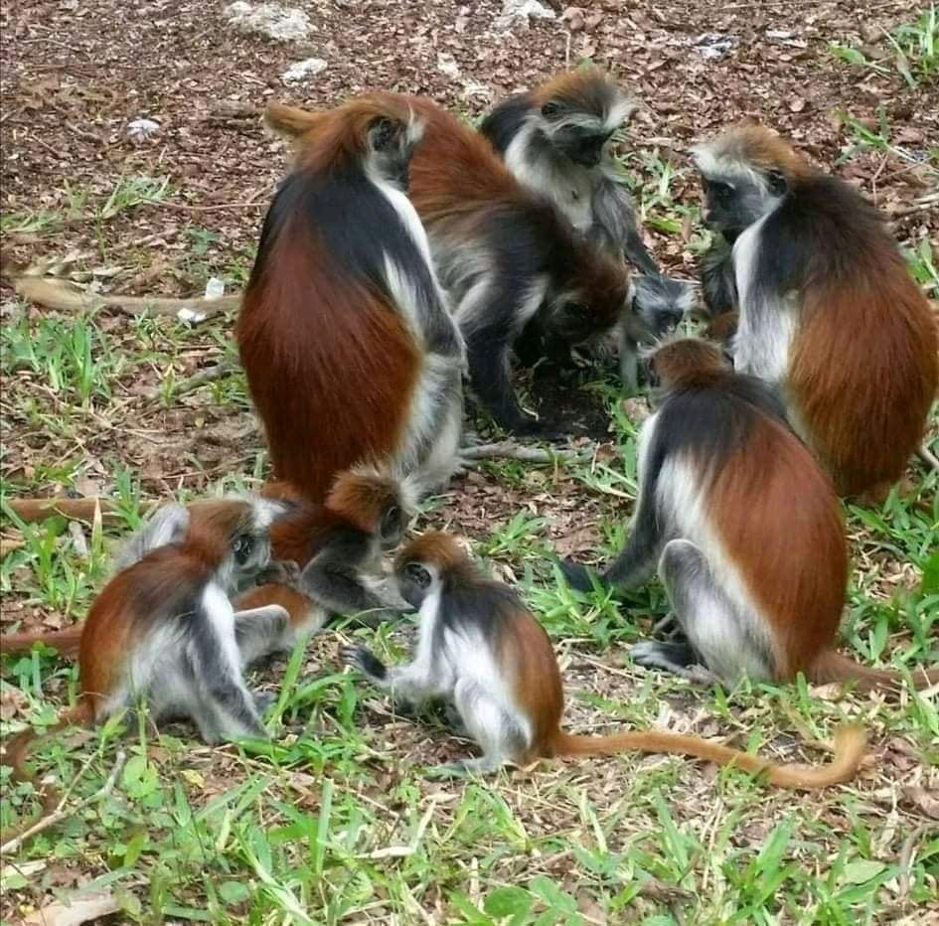

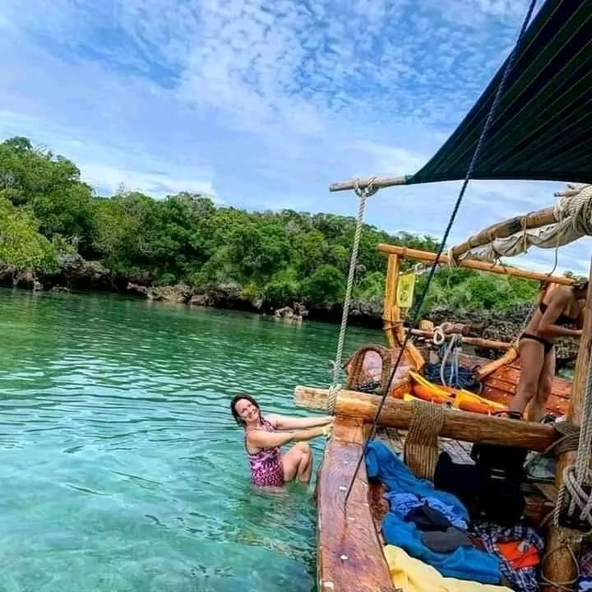



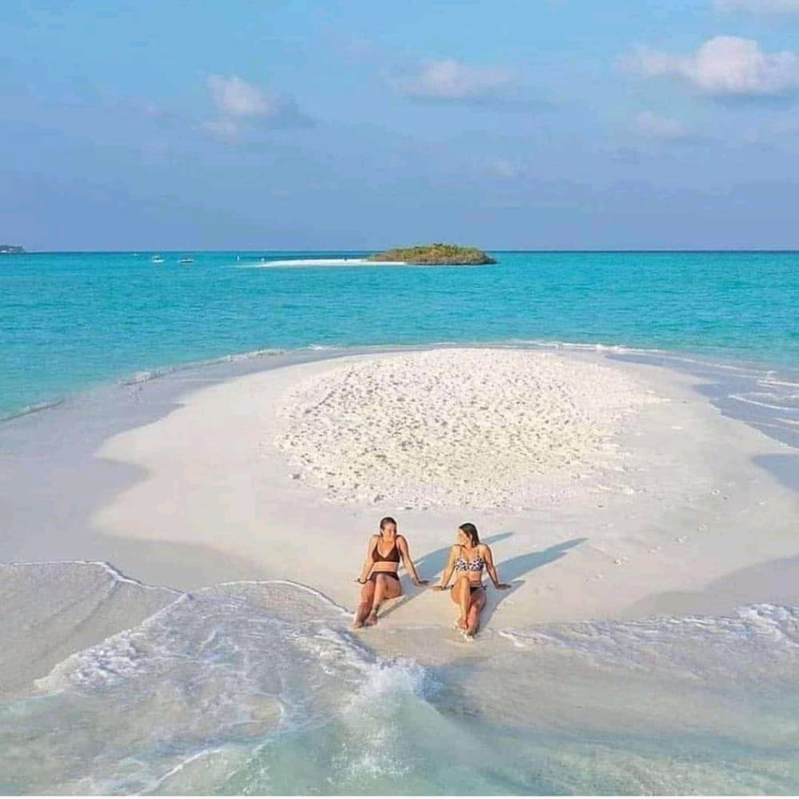

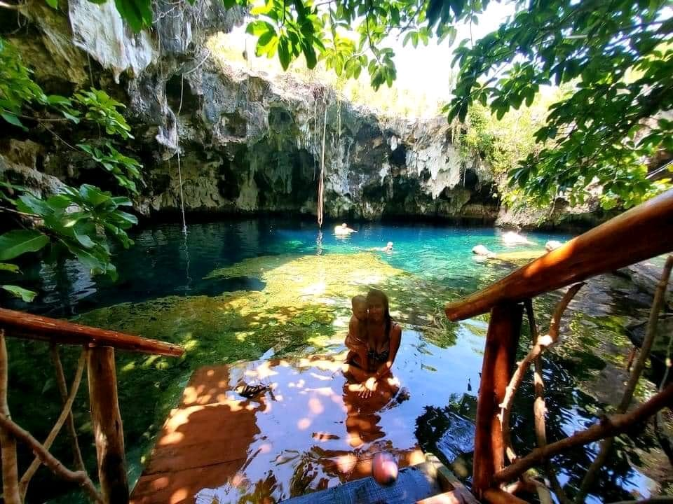

**KIGALI VACATION INCREDIBLE DEAL!!!!!!!!!!!!!!!!!!**

**\*Just for 310,000 Naira**

**FLIGHT – HOTEL -VISA ON ARRIVAL – AIRPORT PICKUP – TOURIST VISIT**

*7 DAY TOURIST PACKAGE FROM LAGOS TO RWANDA

* Destinations: Kigali, Rwanda

* To-&-Fro flight from Lagos to Kigali

* Airport pickup

* Bed & Breakfast Inclusive

* Visit to Kigali Genocide memorial Center

* Age Range: 15- to 85-year-old

* Travel Style: Family, Private, Group

* Operated in English

* Tour length: 7 days

* From: 310,000 Naira

* Itinerary:

Start and end in Lagos! With pick up from Kigali International Airport in Rwanda, to your hotel room with every day breakfast for 7 days stay, a visit to the famous Kigali genocide memorial center.

Visits to other tourism, safaris, lakes, iconic places, wildlife, and remarkable landmarks are not inclusive in the price. Special arrangements can be made for the visits at an affordable price.

For detailed Brochure & Availability of this tour, contact Us through………….

Operated by Travel Team Rwanda Ltd.